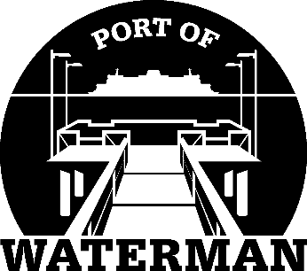

Port of Waterman Meeting Agenda

January 16, 2024

- Swear in Commissioner Reynolds

- Review/Approve Agenda

- Review/Approve Prior Meeting Minutes

- Review/Approve Auditor’s Report

- Review Financial Statement

Old Business:

- Maintenance Update

- IT Support/Cameras

New Business:

- Small Works Roster

- Elect New Chairman

- Commissioner District Reports

